User Acceptance Testing (UAT) Template
Date | 08 March 2025
Team ID | SWTID1741244727154594
Project Name | Fit Flex
Maximum Marks

Project Overview
Project Name: FitFlex
Project Description: A React-based music streaming application that allows users to search, play, and manage music using a third-party API. Features include user authentication, search, playback, playlists, and profile management.
Project Version: v1.0
Testing Period: March 1, 2025 - March 8, 2025

Testing Scope
Features and Functionalities to be Tested
✅ Home Page & Navigation
✅ Exercise Search & Discovery
✅ API Integration for Exercise Data
✅ Filtering Exercises by Body Part & Equipment
✅ Viewing Exercise Details
✅ UI/UX Testing (Responsiveness, Icons, Styling)
✅ Error Handling & Performance Testing

User Stories or Requirements to be Tested
📌 Searching & Viewing Exercises
📌 Filtering Exercises by Body Part & Equipment
📌 Displaying Exercise Details with Instructions
📌 Responsive UI across Mobile, Tablet, and Desktop
📌 Handling API Errors Gracefully

Test Cases
Test Case ID | Test Scenario | Test Steps | Expected Result | Actual Result | Pass/Fail
TC-001 | Load Homepage | 1. Open the application  2. Homepage loads | Homepage should display the Navbar, About, Hero, Search components | [Actual Result] | [Pass/Fail]
TC-002 | Search for an Exercise | 1. Browse and choose from the options in the search bar  2. Click search | Matching exercises should be displayed | [Actual Result] | [Pass/Fail]
TC-003 | Filter by Body Part | 1. Select a body part from the filter 2. View filtered exercises | Exercises should be displayed for the selected body part | [Actual Result] | [Pass/Fail]
TC-004 | Filter by Equipment | 1. Select an equipment type 2. View filtered exercises | Exercises should be displayed based on selected equipment | [Actual Result] | [Pass/Fail]
TC-005 | View Exercise Details | 1. Click on an exercise 2. View details (GIF, instructions, muscles targeted) | Playlist should be created successfully | [Actual Result] | [Pass/Fail]
TC-006 | Mobile Responsiveness | 1. Open the app on a mobile device 2. Navigate through pages | UI should be responsive and properly displayed | [Actual Result] | [Pass/Fail]

Bug Tracking
Bug ID | Bug Description | Steps to Reproduce | Severity | Status | Additional Feedback
BG-001 | Search results take too long to load | 1. Search for exercises  2. Observe slow loading | High | Open | Need API response optimization
BG-002 | Filtering feature not working correctly | 1. Observe incorrect results | Medium | In Progress | Filtering logic needs debugging
BG-003 | UI overlaps on small screen devices | 1. Open app on small devices (iPhone SE) 2. Observe UI distortion | Low | Open | Adjust CSS for better responsiveness

Sign-off
Tester Name: D. SUJITHA
Date: 08:03:2025
Signature: 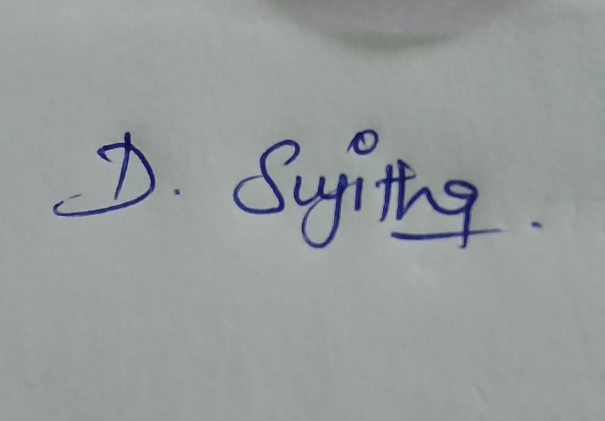

Notes
- Ensure testing covers both positive & negative cases
- Bug tracking should include severity levels & reproduction steps
- Final sign-off required before deployment

